Operation of the DIP switch for Input card:
When pull to “ON/ VE” area as: 0, and pull to number area as: 1
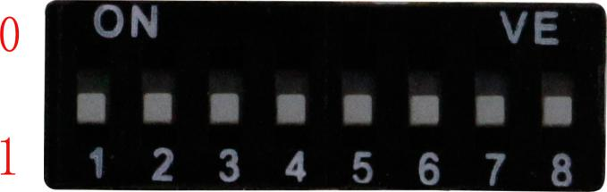

D1, D2 | Input source selection | D1 D2  0 0 CVBS input  0 1 YPbPr input  1 0 VGA input  1 1 DVI Input
D3, D4, D5 | Internal Resolution Selection | D3 D4 D5  0 0 0 1024*768  0 0 1 1360*768  0 1 0 1920*1200  0 1 1 720P/60  1 0 0 Null  1 0 1 Null  1 1 0 1080P/ 50  1 1 1 1080P/ 60
D6 | Audio Selection | 0: Force to 3.5mm audio input  1: Auto adapt
D7 | Auto recognize | 0: Turn on  1: Turn off
D8 | IR Switch | 0: Turn off  1: Turn on
Example: If need to use the internal resolution 1080P/60Hz,
only need to pull D3, D4, D5 as 111
If need to force to 3.5mm audio input,
only need to pull D6 as 0

Operation of the DIP switch for Output card:
When pull to “ON/ VE” area as: 0, and pull to number area as: 1

D1 | Color Space Selection | 0: RBG  1: YUV
D2  D3  D4  D5  D6 | Output Resolution Selection | D2 | D3 | D4 | D5 | D6
 |  | 0 | 0 | 0 | 0 | 0 | 1024*768/60
 |  | 0 | 0 | 0 | 0 | 1 | 800*600/60
 |  | 0 | 0 | 0 | 1 | 0 | 1280*800/60
 |  | 0 | 0 | 0 | 1 | 1 | 1280*1024/60
 |  | 0 | 0 | 1 | 0 | 0 | 1360*768/60
 |  | 0 | 0 | 1 | 0 | 1 | 1366*768/60
 |  | 0 | 0 | 1 | 1 | 0 | 1440*1050/60
 |  | 0 | 0 | 1 | 1 | 1 | 1440*900/60
 |  | 0 | 1 | 0 | 0 | 0 | 1680*1050/60
 |  | 0 | 1 | 0 | 0 | 1 | 1600*1200/60
 |  | 0 | 1 | 1 | 0 | 0 | 1680*1050/60
 |  | 0 | 1 | 1 | 0 | 1 | 1400*900/75
 |  | 0 | 1 | 1 | 1 | 0 | 640*480/75
 |  | 0 | 1 | 1 | 1 | 1 | 800*600/75
 |  | 1 | 0 | 0 | 0 | 0 | 480i/60
 |  | 1 | 0 | 0 | 0 | 1 | 576i/50
 |  | 1 | 0 | 0 | 1 | 0 | 480P/60
 |  | 1 | 0 | 0 | 1 | 1 | 576P/50
 |  | 1 | 0 | 1 | 0 | 0 | 1280*720/24
 |  | 1 | 0 | 1 | 0 | 1 | 1280*720/25
 |  | 1 | 0 | 1 | 1 | 0 | 1280*720/30
 |  | 1 | 0 | 1 | 1 | 1 | 1280*720/50
 |  | 0 | 0 | 0 | 1 | 1 | 1280*720/60
 |  | 1 | 1 | 0 | 0 | 1 | 1080i/50
 |  | 1 | 1 | 0 | 1 | 0 | 1080i/60
 |  | 1 | 1 | 0 | 1 | 1 | 1080P/24
 |  | 1 | 1 | 1 | 0 | 0 | 1080P/25
 |  | 1 | 1 | 1 | 0 | 1 | 1080P/30
 |  | 1 | 1 | 1 | 1 | 0 | 1080P/50
 |  | 1 | 1 | 1 | 1 | 1 | 1080P/560
D7 | Image Mirror function | 0: Rotate off 180 degrees  1: Turn off mirror function
D8 | IR switch | 0: Turn on  1: Turn off

Example:
If need to use RGB color space output, only need to pull D1 as 0
If need to use 1920*1200/60Hz, only need to pull D2, D3, D4, D5, D6 as 01010
If need need to rotate off the image 180°, only need to pull D7 as 0

