EDID Operation for the HDMI 88 Matrix:

Press it to enter EDID set mode. EDID Read：For example, in order to read the EDID of output port OUT5 to input port 1, we need to press the EDID button(the indicator of EDID lights) firstly, press the button 1 on IN side secondly, then press UP or DOWN button to select OUT5, at the same time button 5 on OUT side lights, finally press ENTER button (the indicator of ENTER button will flash for one time ).
1 Way 1:
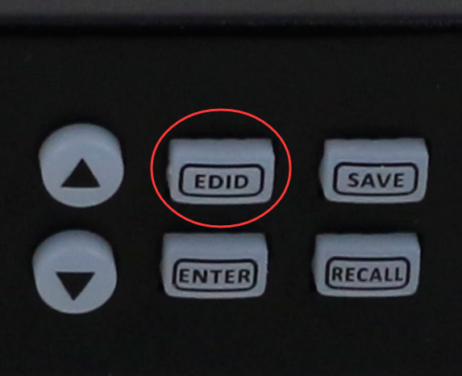
Read OUT5 to IN1:
EDID---1(IN)----UP/DOWN----OUT5----ENTER

Press buttons

2 Way 2:
1) Press “SWITCH” to enter switching interface，choose the needed channel(during 1-8)，enter “EDID” by right-clicking. See Figure 6.8-1.
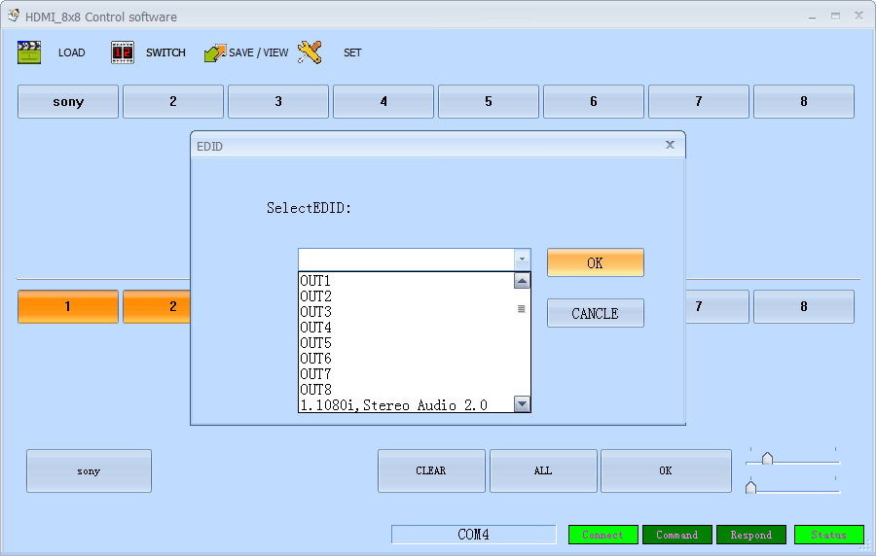
Figure 6.8-1
Select needed EDID parameters, click OK. See Figure 6.8-2.
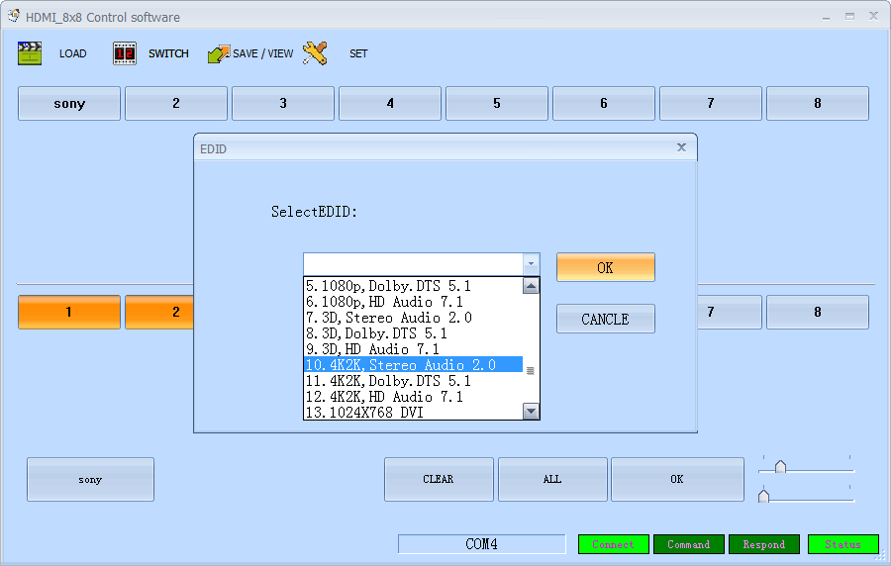
Figure 6.8-2

2) EDID mode table
NO. | EDID description | NO. | EDID description
1 | OUT1(OUTPUT PORT 1) | 5 | 1080p, Dolby. DTS 5.1
2 | OUT2(OUTPUT PORT 2) | 6 | 1080p, HD Audio 7.1
3 | OUT3(OUTPUT PORT 3) | 7 | 3D,Stereo Audio 2.0
4 | OUT4(OUTPUT PORT 4) | 8 | 3D, Dolby. DTS 5.1
5 | OUT5(OUTPUT PORT 5) | 9 | 3D, HD Audio 7.1
6 | OUT6(OUTPUT PORT 6) | 10 | 4k*2k, Stereo Audio 2.0
7 | OUT7(OUTPUT PORT 7) | 11 | 4k*2k, Dolby. DTS 5.1
8 | OUT8(OUTPUT PORT 8) | 12 | 4k*2k, HD Audio 7.1
1 | 1080i,Stereo Audio 2.0 | 13 | 1024x768 DVI
2 | 1080i, DOLBY/DTS 5.1 | 14 | 1920X1080 DVI
3 | 1080i, HD Audio 7.1 | 15 | 1920X1200 DVI
4 | 1080p, Stereo AUDIO 2.0

