EDID Operation for the HDBaseT Transmitter:
The EDID management map is on the bottom panel of the transmitter, and the DIP switch is just right with the map. Specific functions, please check as below:

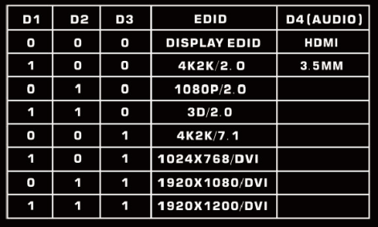
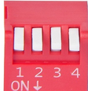
Eg: Users want to use the internal1080P2.0 EDID,
Pull the DIP switch D1,D 2, D3 to 010.
Want to use the Display EDID,
Pull the DIP switch D1,D 2,D 3 to 000.
Want to use the External audio(3.5mm),
Pull the DIP switch D4 to 1
Note: If need to use the internal 3.5mm audio, the video formats must be HDMI.

