**Annabelle and Bailey announce……
Upcoming SPCA Events and Fund Raisers
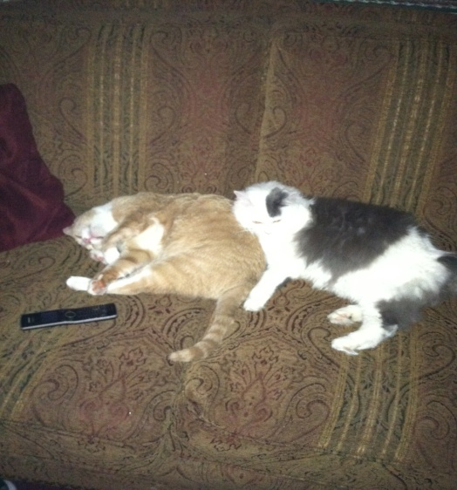

THANK YOU TO ALL SUPPORTERS!
We want to thank all of our Volunteers and Supporters for your continued help and commitment to the SPCA. Your support allows us to continue to provide the services and programs we do to help the lives of all the animals we serve.
Because of your support, the many events we have had so far this year were all very successful
So, again THANK YOU. We are able to help the thousands of animals we serve each year because of all of you!!!
--All the Staff of the SPCA of Luzerne County.

For more information on events please visit the SPCA website at: http://www.spcaluzernecounty.org
**Annabelle and Bailey belong to Kingston Township Manager Kathy Sebastian. Bailey was rescued in 2002 and Annabelle in 2009.

